# Module 3: Action through Automation

# Exercise 1: Create Environment Request Form

## Scenario

In this exercise, you will be creating an environment request form using Microsoft Forms. This form could collect additional information allowing it to be tailored to your individual organization requirements.

### Task 1: Create Microsoft Form

1. While logged in as the lab admin user navigate to [**Microsoft Forms**](https://forms.office.com/) and close the welcome screen.

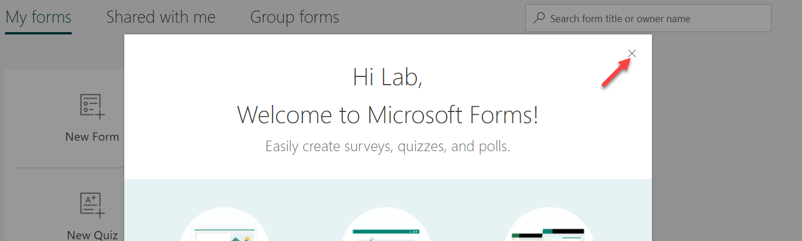

1. Click **New Form**.

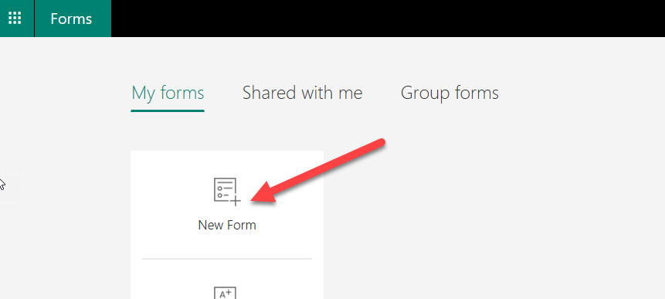

1. Create the Form below, if you need steps, continue the steps here. If you do not need each step, continue to the next exercise.

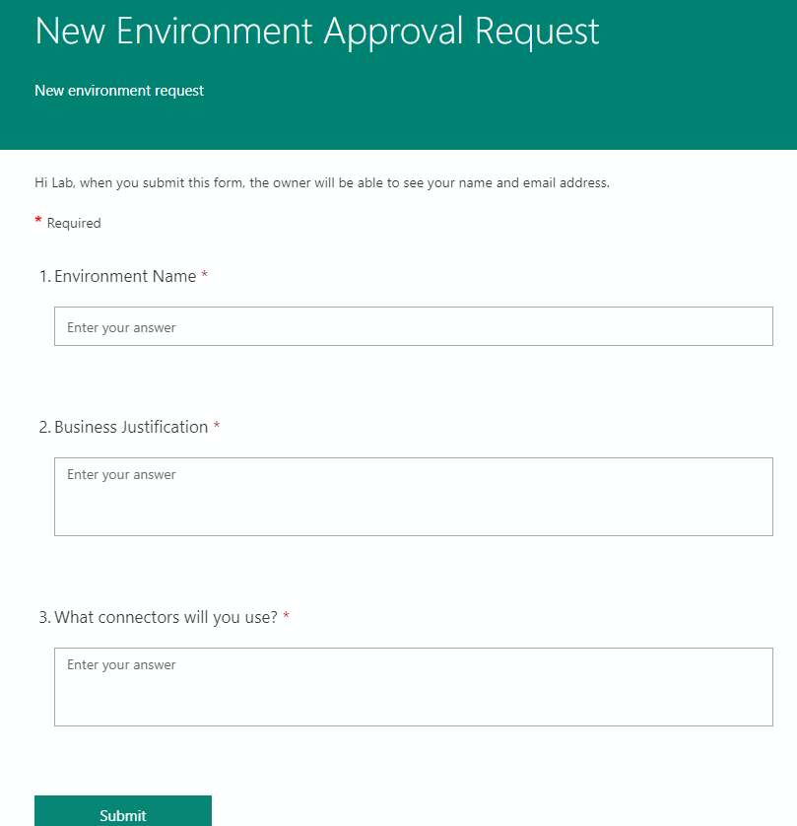

1. Enter **New Environment Approval Request** for title, enter **New environment request** for description, and click **Add new**.

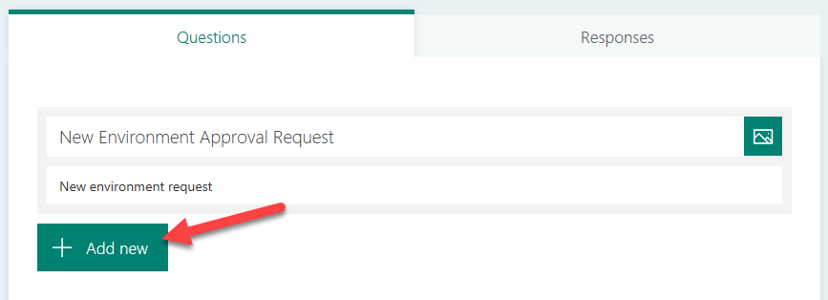

1. Select **Text**.

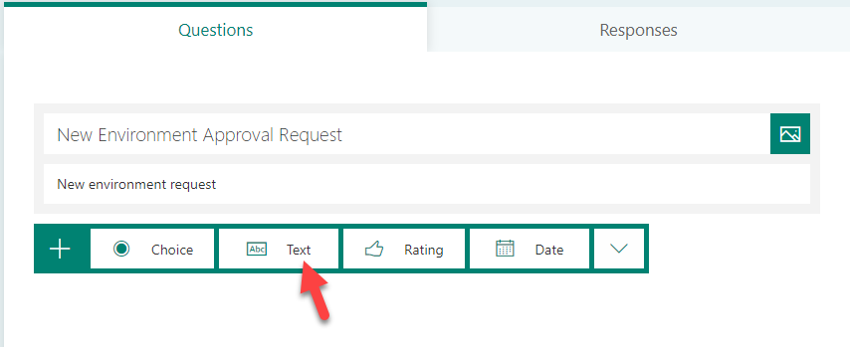

1. Enter **Environment Name**, make the question **Required**, and click **Add New.**

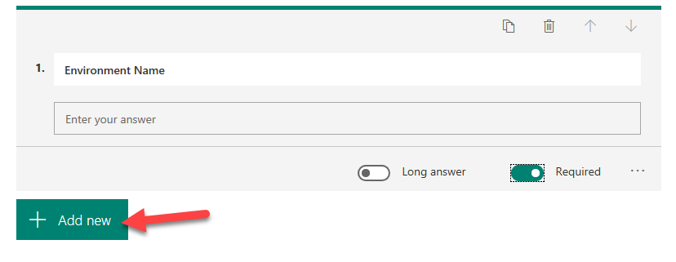

1. Select **Text** again.
2. Enter **Business Justification**, select **Long Answer**, and make it **Required**.

add second question

Select long answer and make it required - screenshot 

1. Click **Add New** and select **Text**.
2. Enter **What connectors will you use?** select **Long Answer** and make it **Required**.

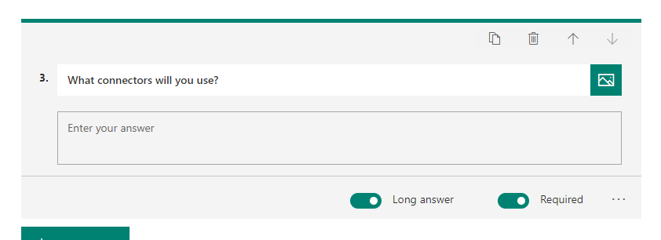

1. The form will be saved automatically.
2. Click **Preview**.

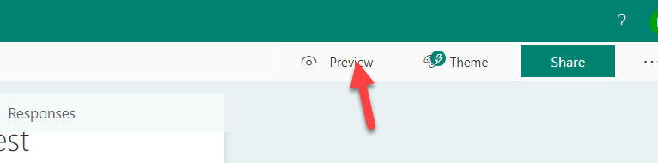

# Exercise 2: Create Environment On Form Submit

### Task 1: Delete your sandbox environment

1. While logged in as the lab admin user navigate to the [Power Platform admin center](https://aka.ms/ppac).
2. Locate and select your sandbox environment that you created in module one named **My Sandbox (Your initials)** in the list of environments.
3. Click the Delete button and **if you have the right environment** confirm the delete by typing the environment name.

### Task 2: Create New Environment Approval Flow

1. Logged in with your **Lab Admin** user, navigate to [**Power Automate**](https://flow.microsoft.com/), and login with your admin user.
2. Confirm that your environment is set to **Power Platform CoE.**   
   Note: This environment is where our CoE starter kit is installed and is intended to be our dedicated admin environment. Even if you don’t use the starter kit, having a dedicated admin environment can be helpful.

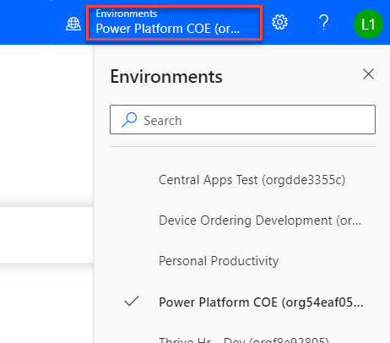

1. Select **My flows**.
2. Click **+ New** and select **Automated from Blank**.

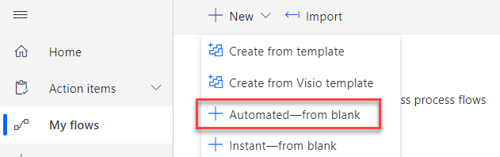

1. Type **New Environment Approval** in the Flow name field.
2. In the **Choose your flow’s trigger** section, search for Microsoft Forms, select When a new response is submitted, and click **Create**.

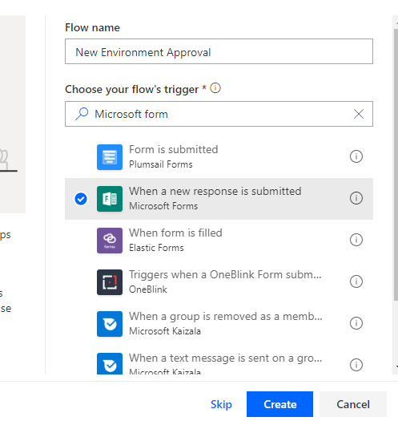

1. Select **the New Environment Approval Request** form you created and click **+ New Step**.

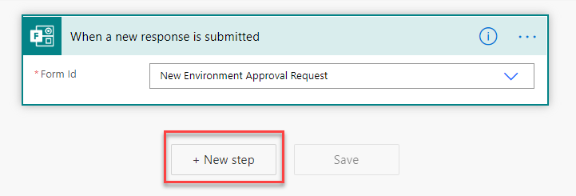

1. Search for **Microsoft Forms** and select **Get Response Details**.

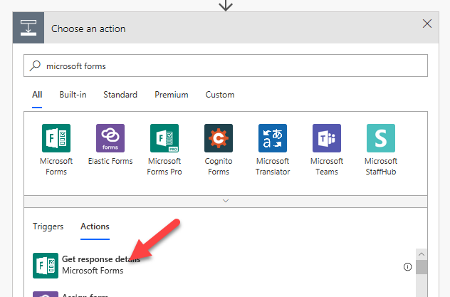

1. Select **New Environment Approval Request** for **Form Id** and click on the **Response Id** field.

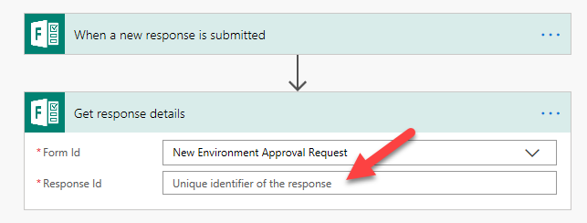

1. Select **Response Id** from the Dynamic content pane.

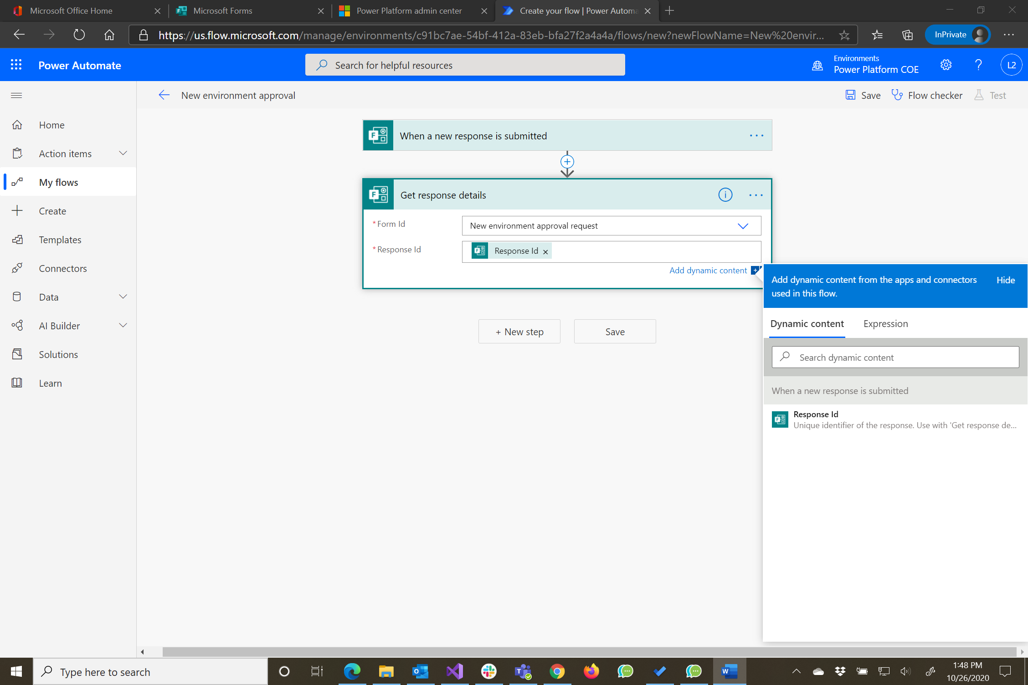

1. Click **+ New step**.
2. Search for **Approvals** and select **Start and Wait for an Approval**.

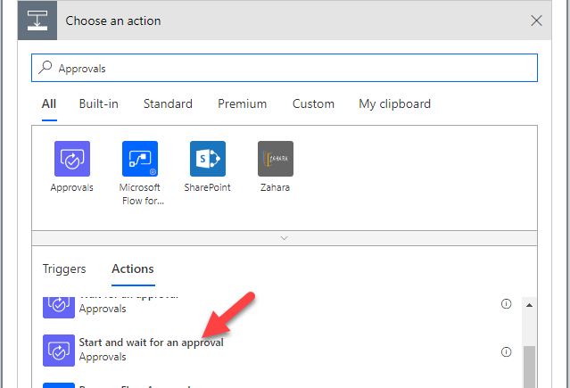

1. Select **First to Respond** for **Approval Type**.

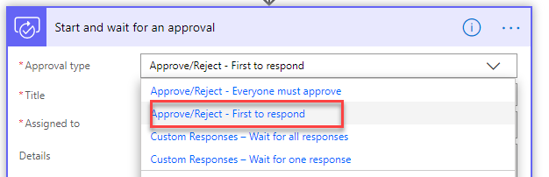

1. Enter **Environment Approval Requested** for Title.
2. Select the user you are logged in as for **Assigned to**.
3. Type **New Environment was requested by:** in the **Details** field.
4. Select **Responders’ Email** from the Dynamic content pane.

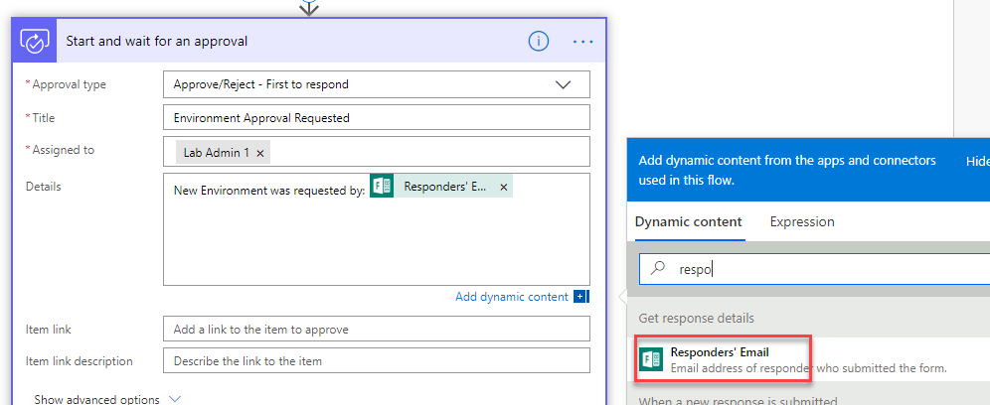

1. Hit the enter key and type **Environment Name:** and select **Environment Name** from the Dynamic content pane.

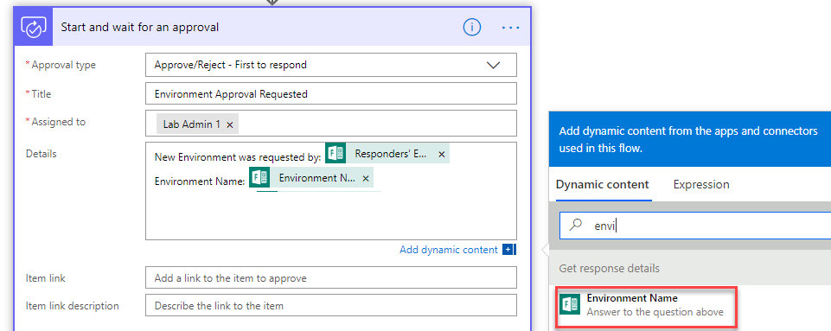

1. Hit the enter key again and type **Business Justification:** and select **Business Justification** from the Dynamic content pane.

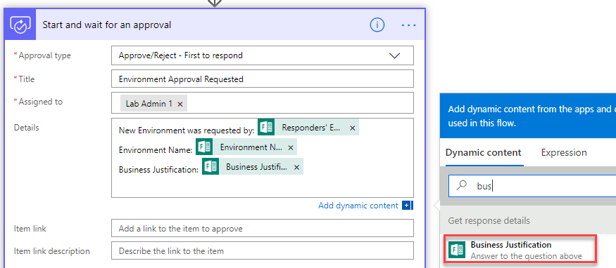

1. Hit the enter key again and type **Connectors:** and select **What connectors will you use?** from the Dynamic content pane.

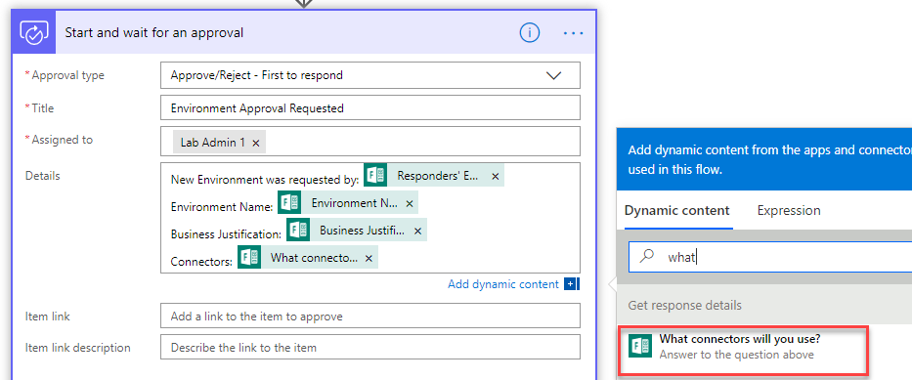

1. Click **+ New step**.
2. Select **Condition** Control.

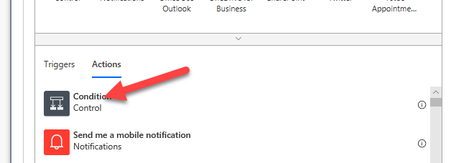

1. Click on the Choose a value field and select **Outcome.**

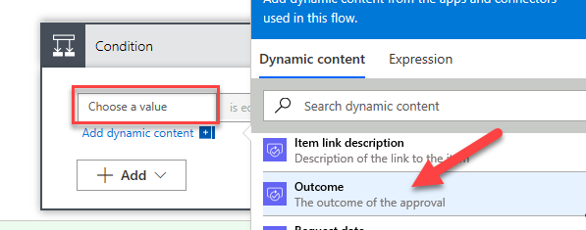

1. Enter **is equals** to for condition, enter **Approve** for value, and click **Add an action** in the **Yes** branch.

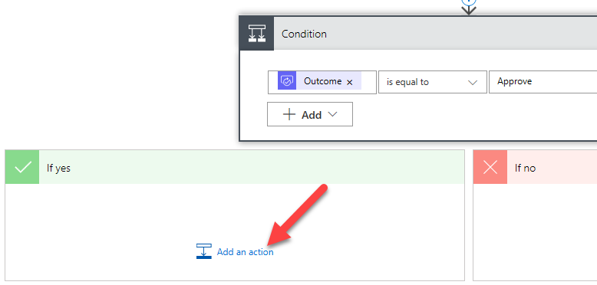

1. Search for **Power Platform** and select **Power Platform for admins**.

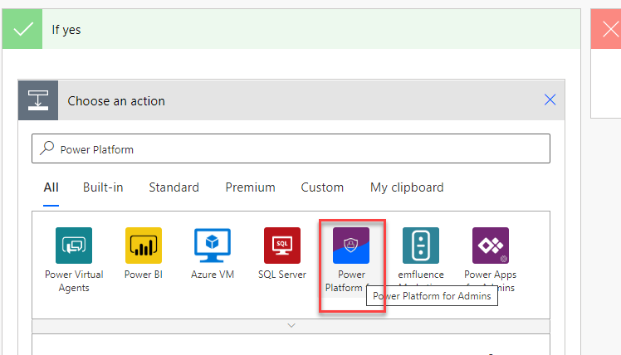

1. Select **Create Environment.**

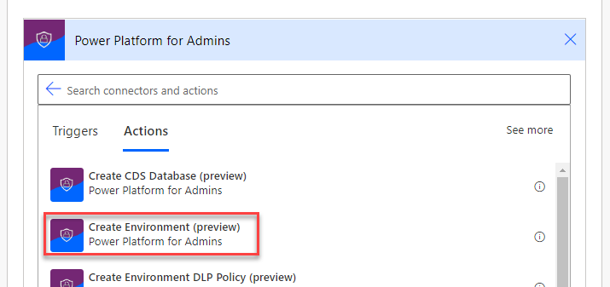

1. Enter unitedstates for the **location** and click on the **Display Name** field.

Note: Location determines the region for the environment, in a real process you might allow this to be auto determined by the user location or something the requester provides.

1. Select **Environment Name** from the Dynamic content pane.

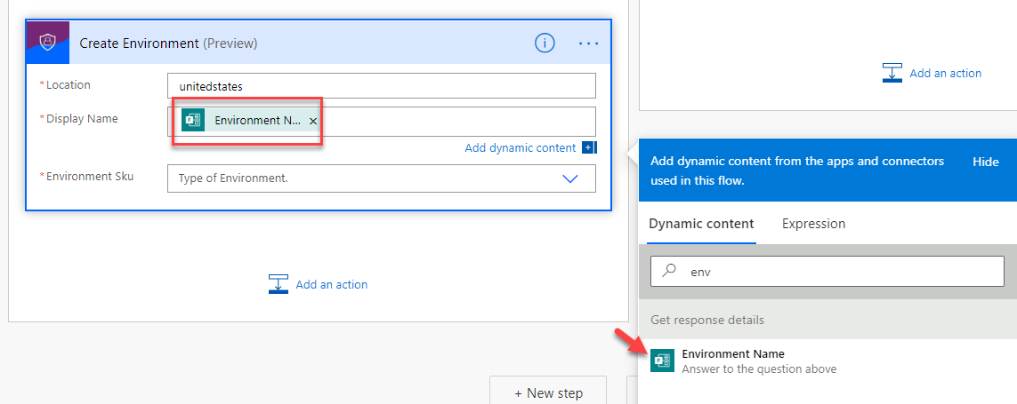

1. Select **Trial** for **Environment Sku**.
2. Click **Save**. Do not navigate away from this page.

### Task 3: Create Database and Notify User

1. Click **Add Action** under Create Environment.

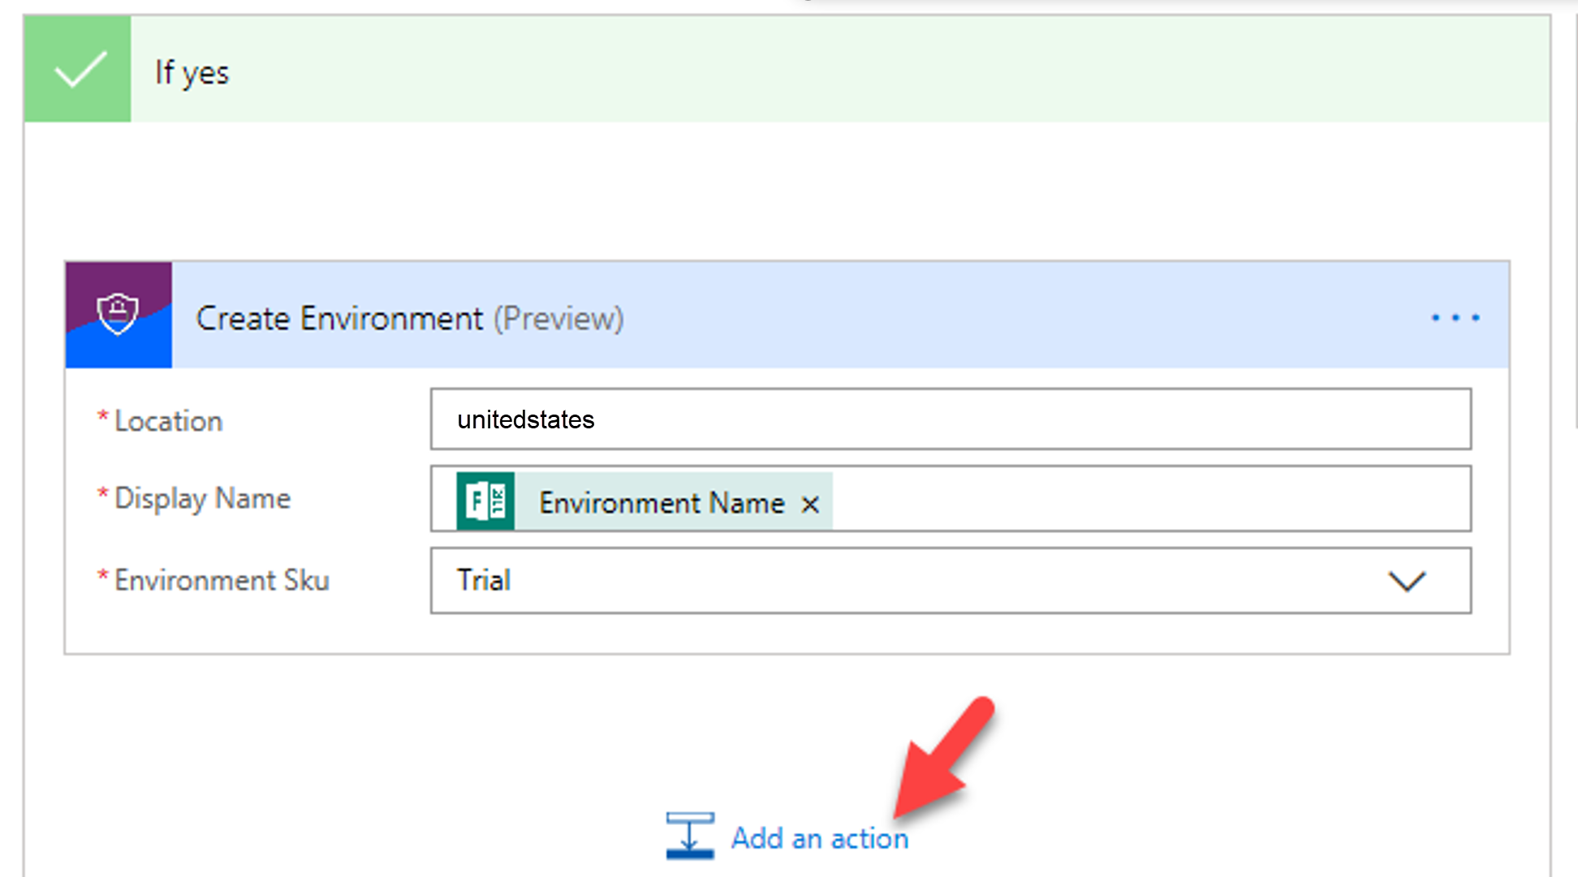

1. Search for **Power Platform** and select **Create CDS Database** **(preview).**

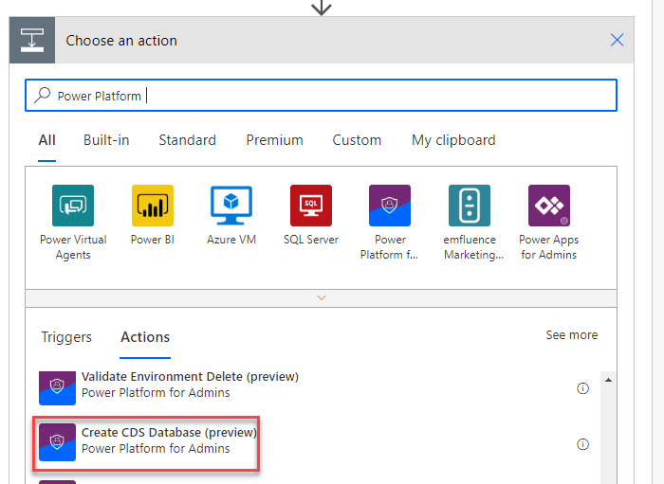

1. Click on the **Environment Name** dropdown and select **Enter Custom Value**.

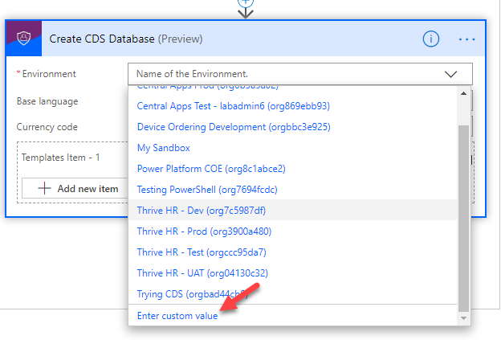

1. Select Name from the Dynamic content pane.

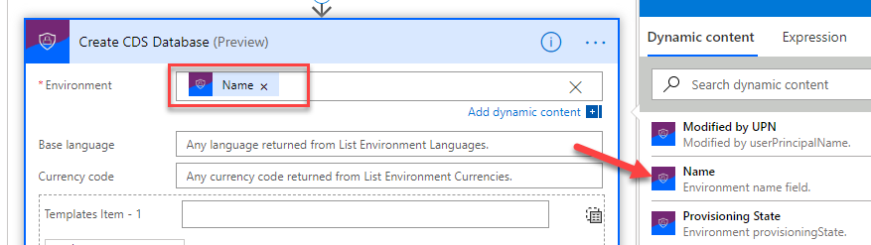

1. Enter **1033** for Base Language and enter **USD** for Currency Code.
2. Enter **D365_CDSSampleApp** for Template Item.
3. Click **Add an action**.

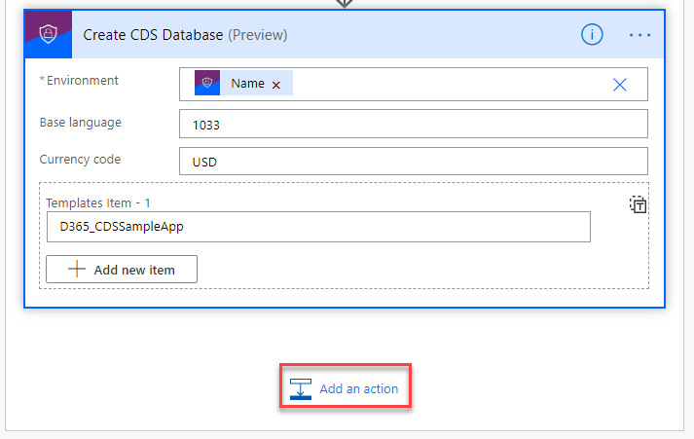

1. Search for **Send Email** and select **Send an email (V2) Office 365 Outlook.**

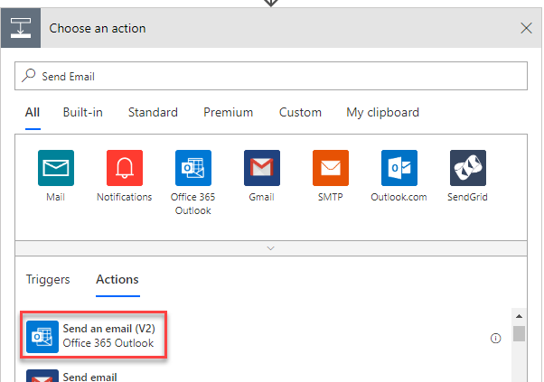

1. Click on the **To:** field and select **Responder’s Email** for the Dynamic Content pane.
2. Enter **Your environment was created** for **Subject**.
3. Enter **Environment** in the **Body** field and select **Display Name** from the Dynamic Content pane under the **Create Environment** step.
4. Add **was created**.
5. Your email should look like the image below.

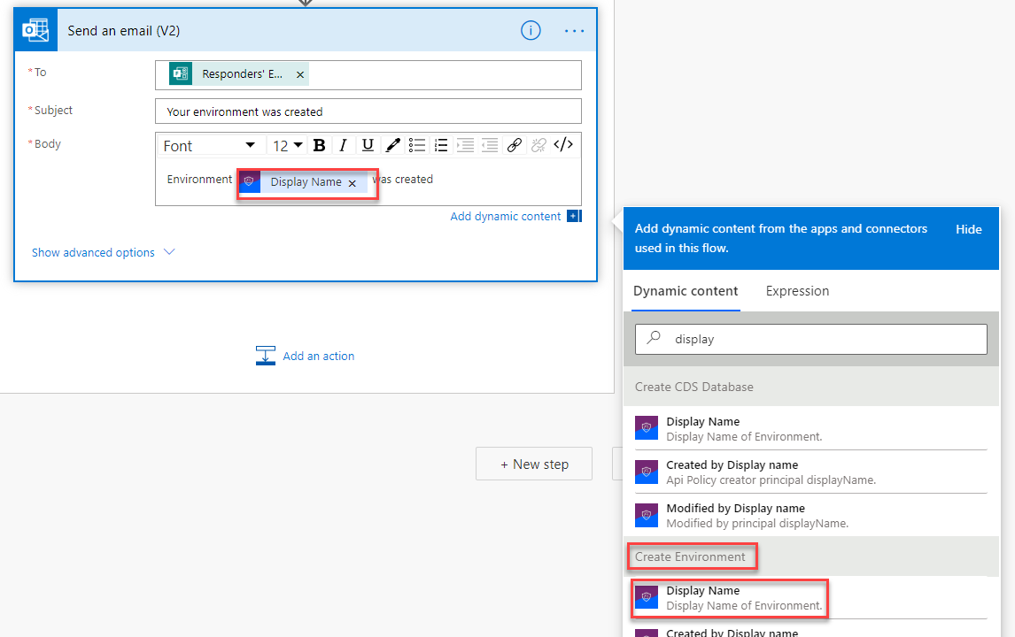

1. Go to the **No** branch and click Add an Action.
2. Search for Send email and select **Send an email (V2) Office 365 Outlook**.
3. Click on the **To:** field and select **Responder’s Email** from the Dynamic Content pane.
4. Type **Rejected environment request** for **Subject**.
5. Enter **Your request for new environment was rejected** in the **Body**.
6. Your email should now look like the image below.

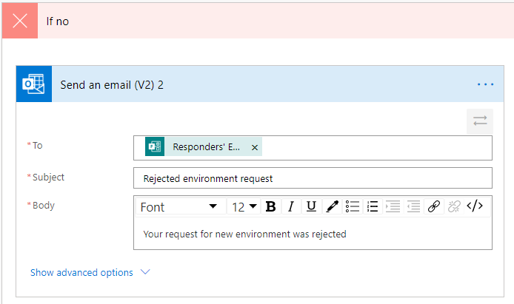

1. Click **Save**.

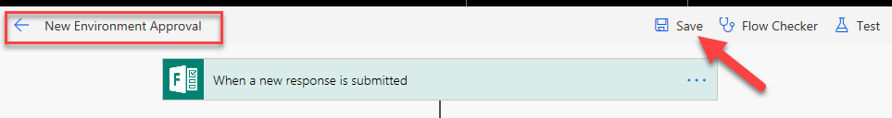

1. Click **Flow Checker** and make sure there are no errors.

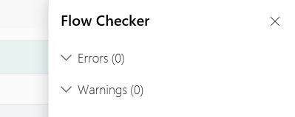

1. Close the **Flow Checker** pane.
2. Click on the **Back** button.

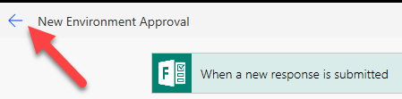

### Task 4: Test the Flow

1. Navigate to [Microsoft Forms](https://forms.office.com/) and click to open the form you created.

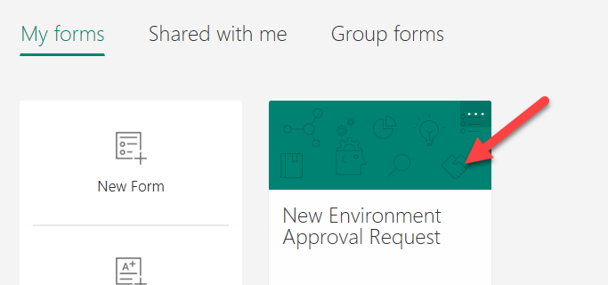

1. Click **Share** and **Copy** the link.

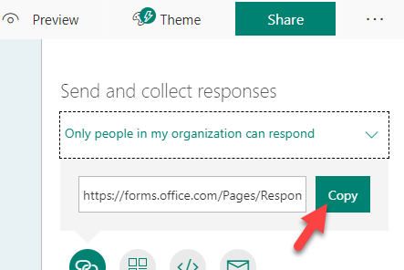

1. Paste the link in the browser and navigate to it.
2. The form should load. Provide an Environment Name of **Central Apps Test,** Business Justification and the connector Common Data Service. Note: For the purposes of this course, we will be using this environment we created here later in another lab to deploy the Device Ordering solution using Azure Dev Ops, for that lab it will serve as the Test environment that is why we are suggesting naming it Central Apps Test. In real word use, most likely it would be a team/project development environment that would be requested using a form like this.
3. Click **Submit**.

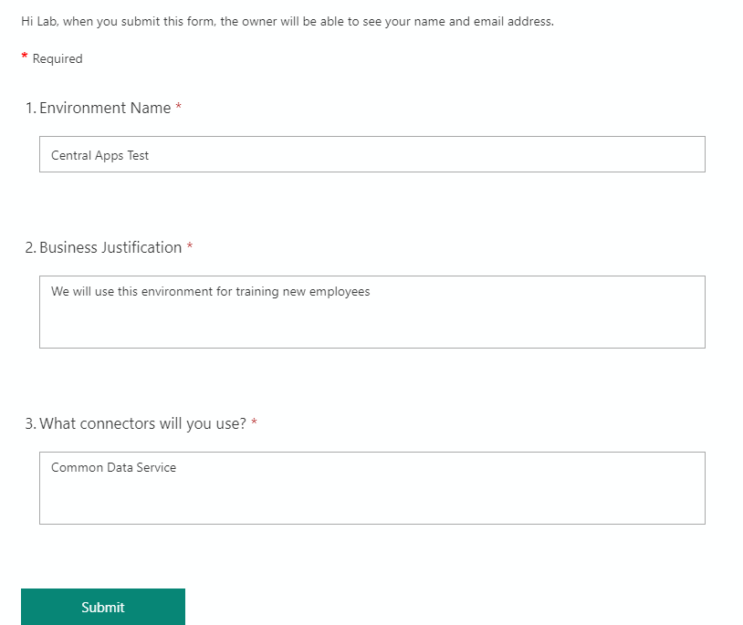

1. Go back to **My flows** list and open the flow you created.

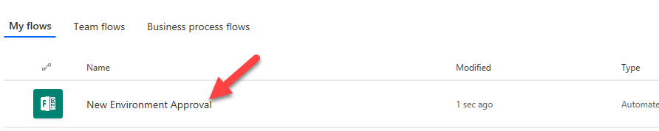

1. You should see the flow running. Click to open it.

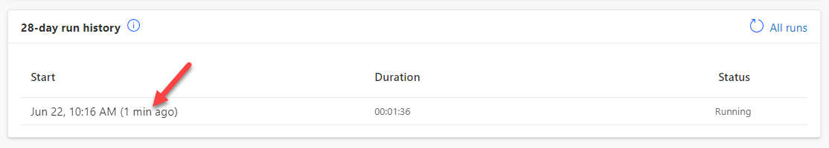

1. The flow is waiting for the approval.

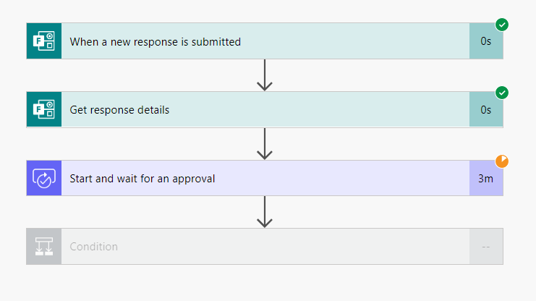

1. Start a new browser tab and navigate to [Outlook](https://outlook.office365.com/).
2. You should have approval request email, click to open it.

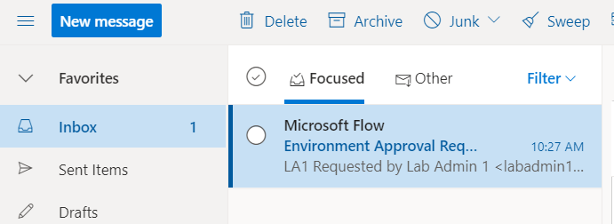

1. Click **Approve**.

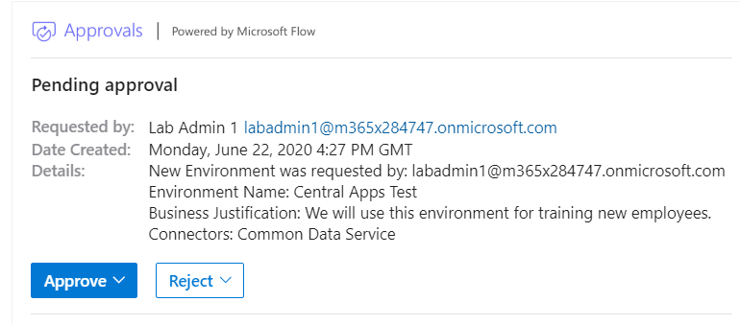

1. Click **Submit**.

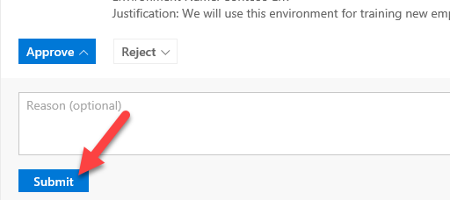

1. Go back to the flow browser tab.
2. The flow should succeed.

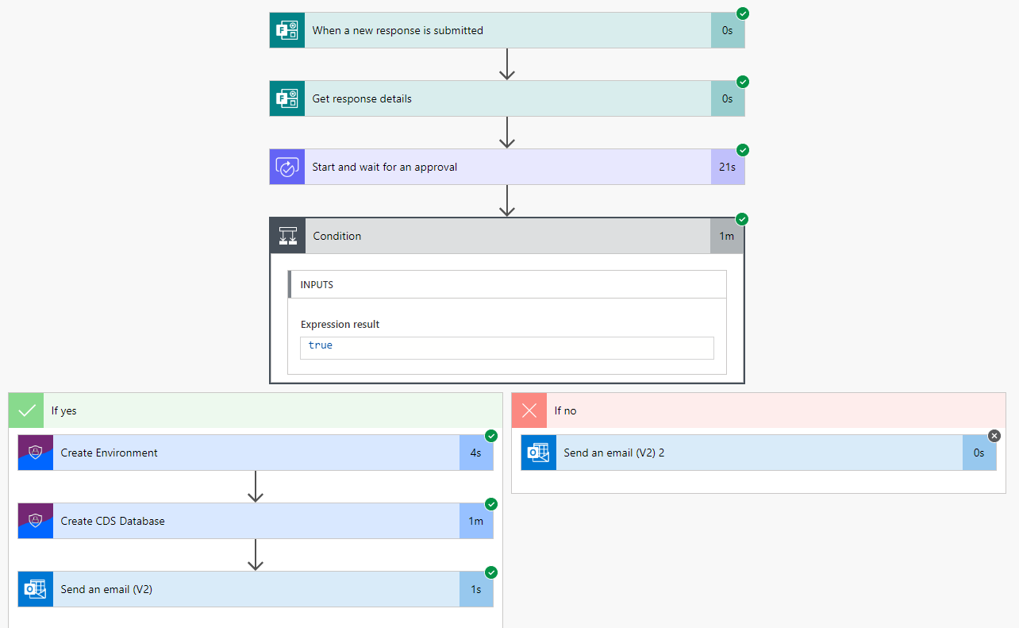

1. Navigate to [Power Platform admin center](https://admin.powerplatform.microsoft.com/) and select Environments. The new environment should be listed there.

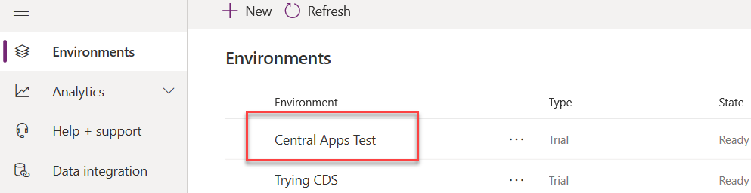

1. You should also get an email.

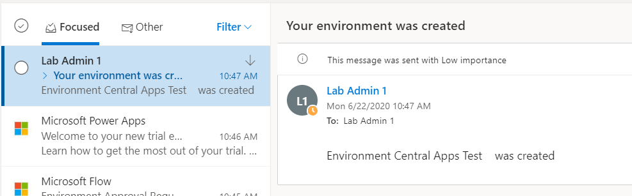

1. You may test for request rejection if you like.

# Exercise 3: Application Compliance Process

In this exercise, you will be walking through the application compliance process that has been put in place using the CoE Starter Kit. As part of this you will be playing both the role of the application developer and the administrator seeing both sides of the process.

The goal of this process is to help IT that doesn't know what all these apps are intended for or how to support individual apps when the helpdesk is called, and it's unclear whether all the apps are being maintained to any standard. They can see details like the description and number of shared users from the Power Apps for Admins connector, but they need to communicate directly with the app owner to fully understand the situation around the apps. Especially in a large organization, it's not feasible for the IT team to be responsible for manually reaching out to each app owner individually, and those details can't be stored in email conversations.

To automate this, a flow **Admin | Compliance Detail Request** is used to iterate through all the apps in the tenant and check whether the apps are compliant. If the owner hasn't submitted a business justification and the app was shared broadly (in this example, with more than 20 users or at least one group), the flow sends the owner an email to notify them that their specific app isn't compliant with policy. The email contains a link to the Developer Compliance Center canvas app, where the owner can provide the business justification details in a form submission. The Developer Compliance Center app also contain details about the compliance thresholds and has links to the app settings, so the owner can configure the description and republish if needed.

This app auditing sample process showcases how your CoE department or IT administrators can automate an auditing process on an app-level basis to gather additional information about an app, like business justification and the impact of an outage, from the maker

### Task 1: Complete Developer Compliance

In this task you will be performing the role of the developer and completing the application information that will be requested by the automated process.

1. When the full process runs the maker will receive an email like the following with a link to the Developer Compliance Center. For our exercise just briefly review and then we will launch the app from the maker portal.

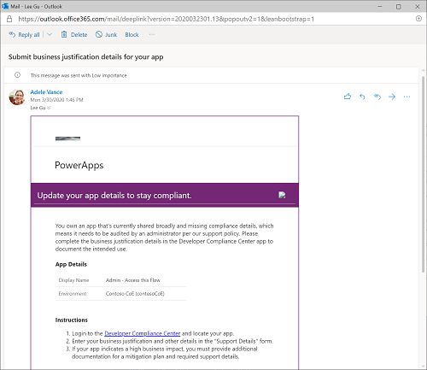

1. Navigate to the maker portal and select the **Power Platform COE** environment.
2. In Apps, select the **Developer Compliance Center** and click Play.
3. The application will list all the apps that you are the owner of. The red circle indicates the apps current level of compliance. You should see at least one app that has the name lab admin and your number. Click on the **Details** button.

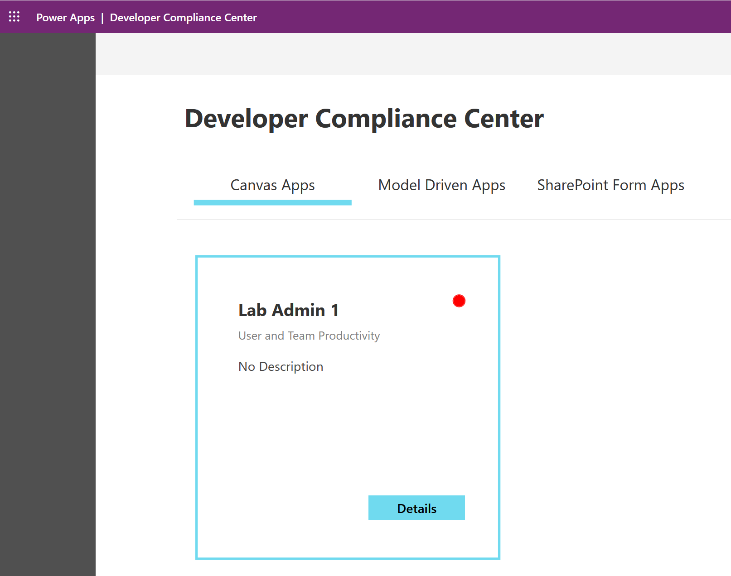

1. Review the App Compliance section which gives clear guidance on what needs to be updated.

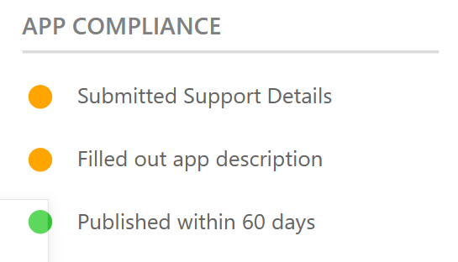

1. In the Support Details section fill in the all the fields of information for your application; you can make it as detailed as you want, but submit information for each field in this section.
2. Normally we would also go adjust the description by editing the app, but for the purposes of this lab will skip that.
3. Click the **Submit button** to save the information about the application.

### Task 2: Admin Review

In this task you will be performing the administration review of the application details that was submitted by the developer.

1. In the maker portal, with **Power Platform CoE** environment selected click on Apps.
2. Play the Power Platform Admin view app.
3. In the app, click on **Apps** in the left navigation and change the view to **Admin Review**. This view will show all the applications that have met the requirements for a review making it easier for the admin to know what to focus on when they are reviewing applications.

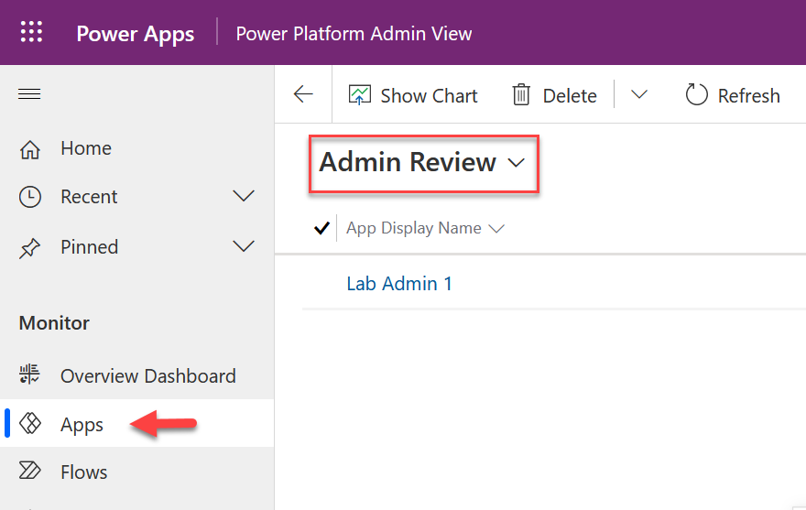

1. Locate your application it will be Lab Admin and your # and double click on it to open the detail view.
2. Click on **Validate Maker Business Requirements** in the process guide. This shows you the current stage of the review process and highlights the progress. Notice it says the maker provided the business requirements.

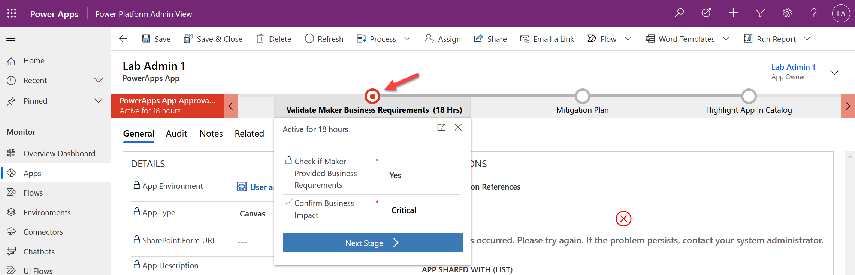

1. Review the information provided by the maker by clicking on the Audit tab.

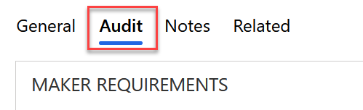

1. After reviewing you can advance the process to the next stage by clicking the Next Stage.

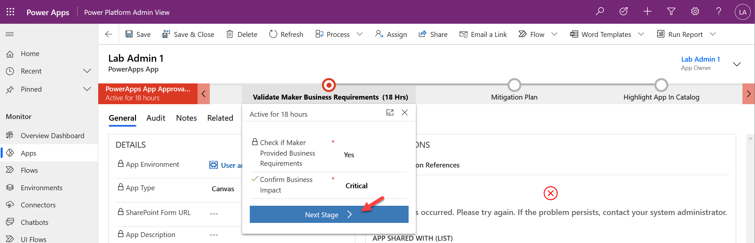

1. In the Admin section change the Risk Assessment to Minor.
2. The process guide will now have either Mitigation plan as the active stage or Access risk depending on if the maker indicated the app is critical or not, click Next Stage again to advance.
3. In the final stage you can choose a category for the app in the catalog and indicate if it was featured. Make your selections and then click Finish.
4. You have now completed the full review process. This is an example that is provided with the starter kit you can tailor the process to your own organization needs including adding stages and steps to the process and requiring additional data from the maker.

# Exercise 4: Welcome New Makers (Optional if you have time)

In this exercise, you will be importing a pre-built flow that is designed to identify new app makers and welcome them by sending an email with some information for new makers. Additionally, the flow will add the user to an Office 365 group, so you have an easy way to communicate with all the makers in the company.

### Task 1: Create Office 365 Group

1. Navigate to [Azure portal](https://portal.azure.com/)
2. Select **Azure Active Directory**.

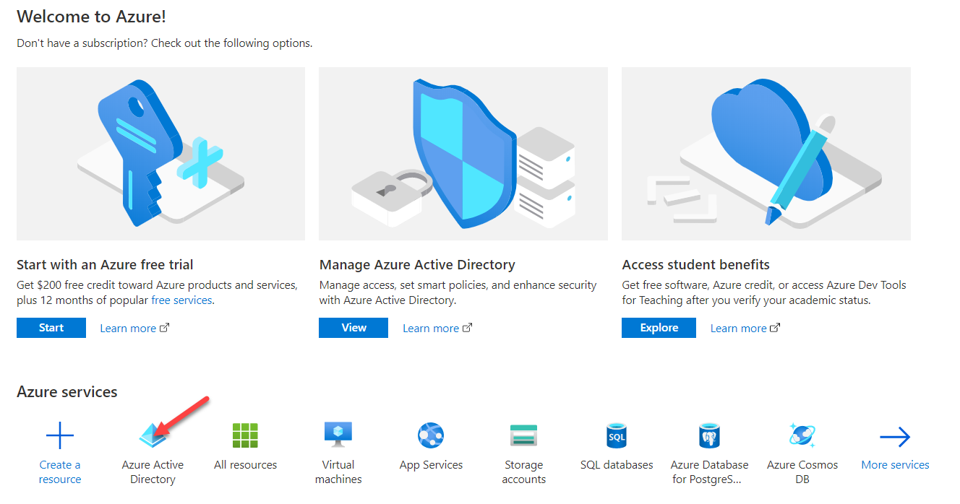

1. Select **Groups**.

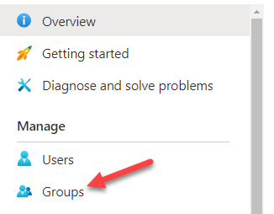

1. Click **+ New Group.**

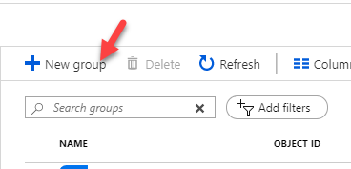

1. Select **Office 365** for Group Type, enter **Lab Admin Your# Makers** for Group Name, select **Assigned** for Membership Type and click **Create**.

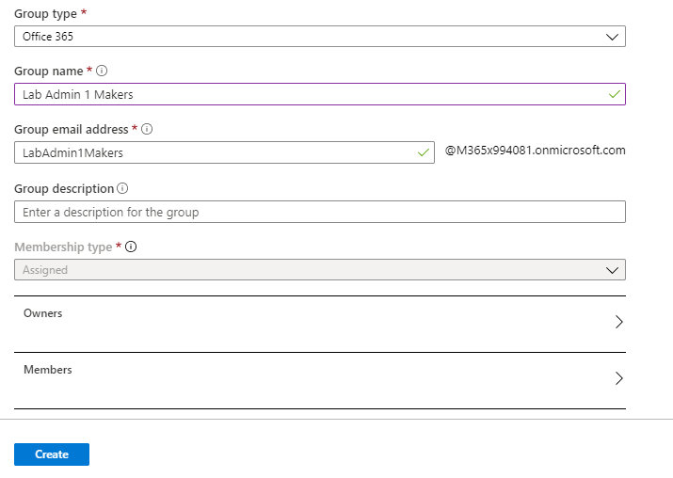

1. Open the group after it gets created.

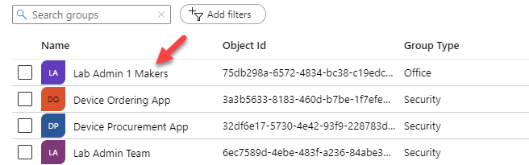

1. Select **Properties** and copy the **Object ID**.

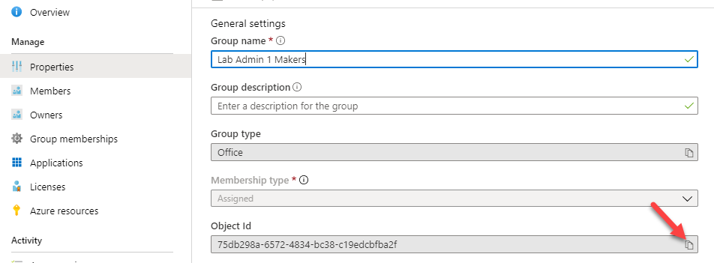

1. Paste the object ID to a notepad, you will need it in future step.

### Task 2: Import Flow

1. Navigate to [**Power Automate**](https://flow.microsoft.com/)
2. Make sure **Power Platform COE** environment is selected. Note: While we are using this here, in your own tenant you might do this in an admin focused environment or where you have installed the CoE Starter Kit.

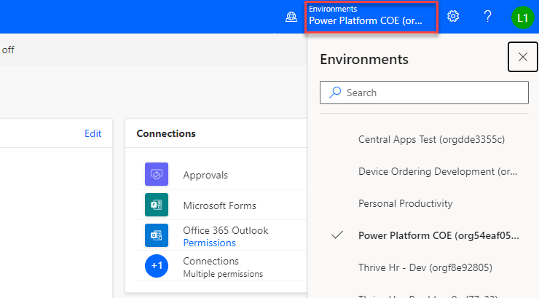

1. Select My **Flows** and click **Import**.

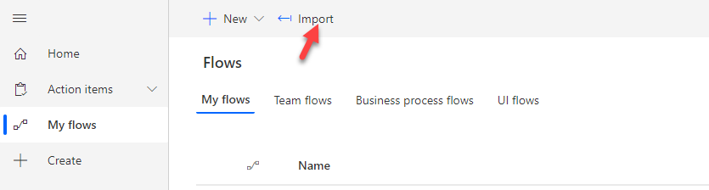

1. Click **Upload**.
2. Select the **Send Welcome Email** zip file and click **Open**. This will be in your lab resource files you downloaded named SendWelcomeEmailToNewPowerAppsMakers_20190529192359.zip

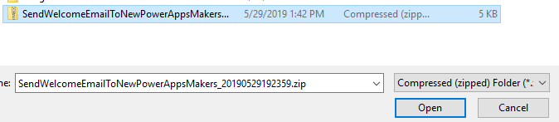

1. Click Configure for the flow.

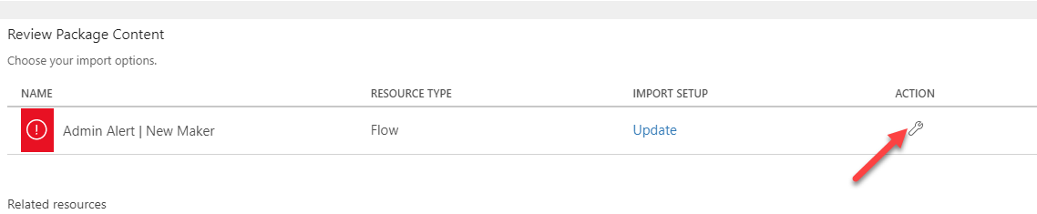

1. Select **Create as new** and click **Save**.

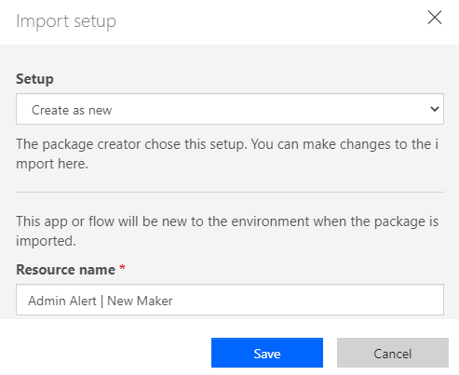

1. Click **Configure** for **Power Platform for Admin Connection**.

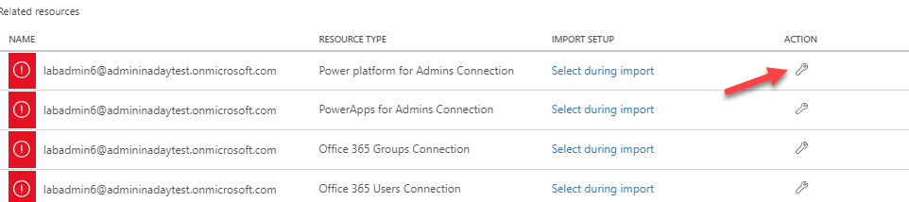

1. Select the available connection and click **Save**.

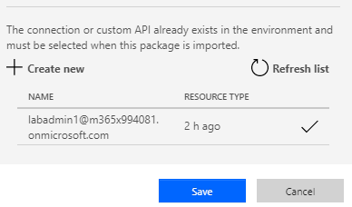

1. Click Action for **Office 365 Outlook Connection**.
2. Select the available connection and click **Save**.
3. Click **Configure** for **Power Apps for Admin Connection**.

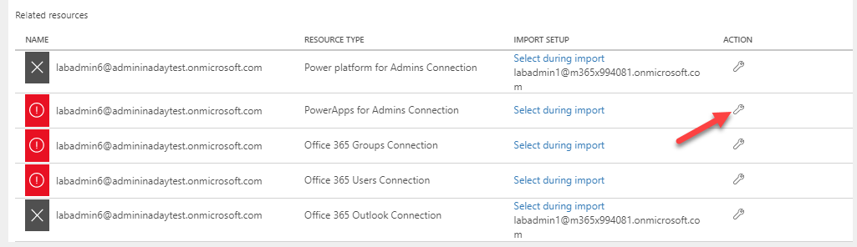

1. Click select the available connection and click **Save**.

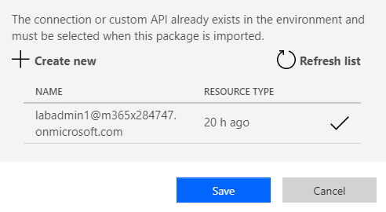

1. Click **Configure** for **Office 365 Group Connection**.
2. Click **Create new**.

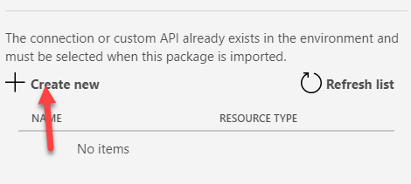

1. Click **+ New connection**.

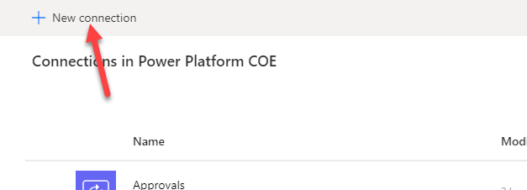

1. Search for **Office 365 Groups** and click **Add**.

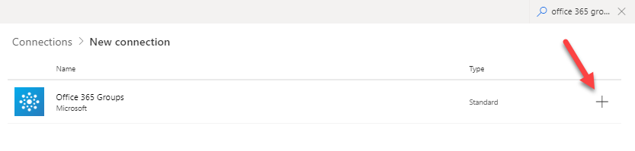

1. Click **Create**.
2. Login with your maker credentials.
3. You should now have the connections listed in the image below.

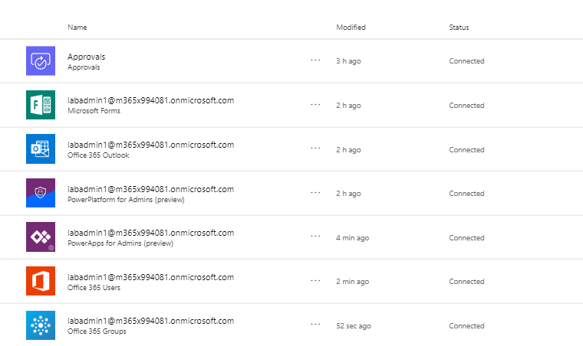

1. Go back to the Flow import.
2. Click **Refresh list**, select the connection you just added, and click **Save**.

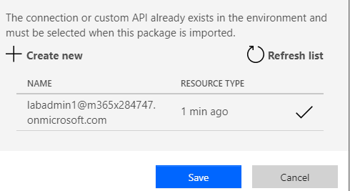

1. Click Action for **Office 365 Users Connection**.
2. Select the available connection and click **Save**.
3. Repeat this for the **Office 365 Outlook Connection**.
4. Click **Import** and wait for the import it to complete.

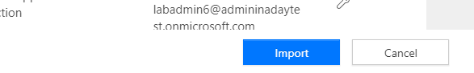

1. The flow should import successfully.

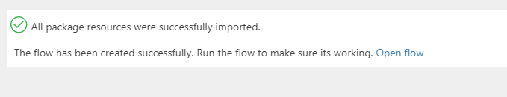

### Task 3: Edit and Test Flow

1. Navigate to [Power Automate](https://flow.microsoft.com/) and make sure you have the **Power Platform CoE** environment selected.
2. Select My **Flows**.
3. Locate the flow you imported and click **Edit**.

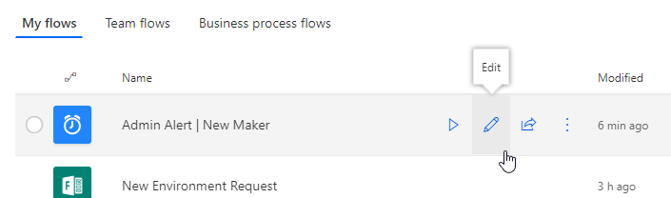

1. Expand the **Recurrence** and make sure the flow is set to run once a day.

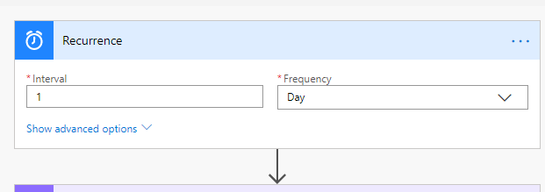

1. Expand the **Office Group ID** step.
2. Clear the current **Group ID**.
3. Copy the **Group ID** from your notepad and paste it here.

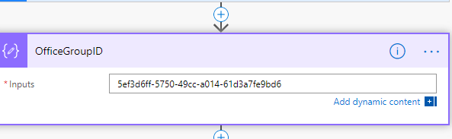

1. You may examine the steps of the flow.
2. Click **Save**.
3. Click on the back button.

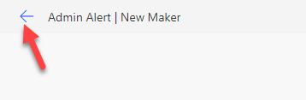

1. Click **Run**.

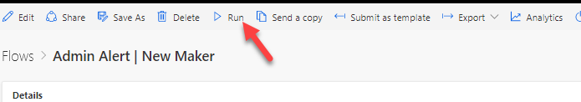

1. Click **Run Flow**.
2. Click **Done**.
3. **Refresh**.
4. Your flow run should succeed.

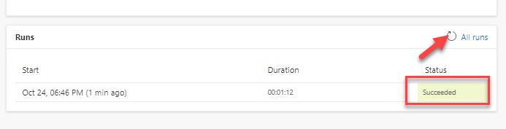

1. Go back to [Azure portal](https://portal.azure.com/)
2. Select **Azure Active Directory**.
3. Select **Groups** and open the group you created.

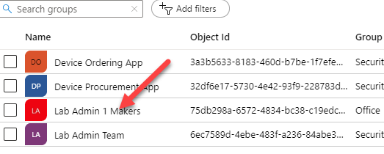

1. Select **Members**. You should have at least one member.

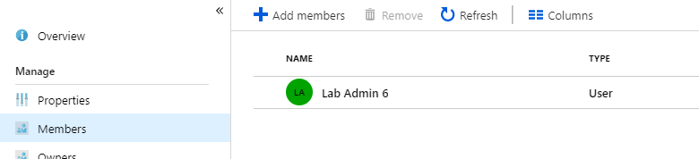

1. Navigate to [Outlook](https://outlook.office.com/) .
2. You should get a welcome email. Open the email. If you don’t get an email, it is probably because you didn’t create an application in the past 24 hours, create a new Power App and run the flow again.

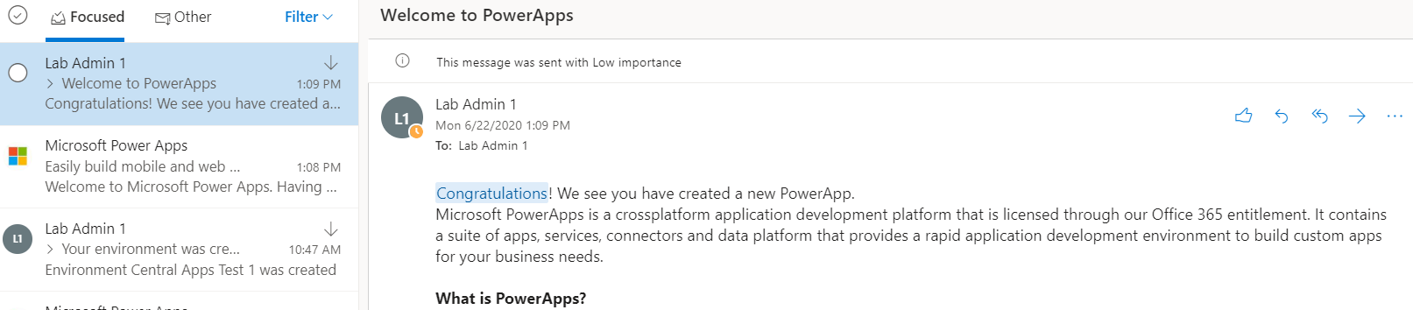

# Exercise 5: Manage Dataverse for Teams environments (Optional if you have time)

In this exercise, you will be utilizing components of the CoE Starter Kit to manage Dataverse for Teams environments, and gather business justifications from Team owners who add Dataverse for Teams environments to their Teams.

Before following the steps, get familiar with the process: [Microsoft Dataverse for Teams environment management - Power Platform | Microsoft Docs](https://docs.microsoft.com/en-us/power-platform/guidance/coe/teams-governance)

### Task 1: Turn on Dataverse for Teams environment management flows in the CoE Starter Kit

1. Navigate to the maker portal and select the **Power Platform COE** environment.
2. Select **Solutions**
3. Select **Center of Excellence – Governance Components** andturn on the **Microsoft Teams Admin | Ask for Business Justification** flow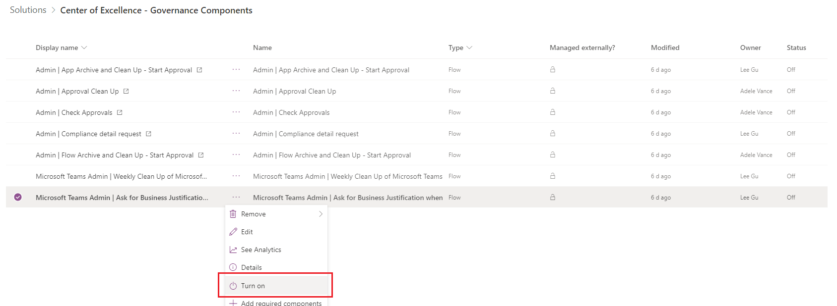

### Task 2: Create a Team and Dataverse for Teams environment

1. Navigate to <https://teams.microsoft.com/> (and select continue in browser if prompted)
2. Select **Join or create a team** and create a new team from scratch  
   Graphical user interface, application

   Description automatically generated
3. Select **Private Team** and name your team **Lab Admin # Team**
4. **Create** your team  
   Graphical user interface, application, Teams

   Description automatically generated
5. **Skip** adding further members to your team
6. Select **…** to add an appand **Power Apps (Preview)**Graphical user interface, application, Teams

   Description automatically generated
7. Select **Create an app**Graphical user interface, application, Teams

   Description automatically generated
8. Select your teamGraphical user interface, text, application

   Description automatically generated

### Task 3: Manually start the environment sync to kick off the flow to ask for business justification

Typically, the flow to ask for business justification runs on a daily basis. We will kick this off manually. As you are sharing a CoE environment with other lab attendees, only one person (or the lab instructor) will have to follow the below steps and run the flow.

1. Navigate to the maker portal and select the **Power Platform COE** environment.
2. Select **Solutions**
3. Select **Center of Excellence – Core Components**
4. Select **Admin | Sync Template v2**  
   **A picture containing application

   Description automatically generated**
5. Select **Run  
   **
6. This kicks off the sync flow that looks for new environments, and will trigger the flow that asks for business justification when a new Dataverse for Teams environment is created.

### Task 4: Provide business justification for your environment and review all Dataverse for Teams environments

1. Once the **Admin | Sync Template v2** has finished, go back to Teams. You will see a prompt to provide a business justification for your new environment.
2. Submit a business justification  
   **Graphical user interface, text, application

   Description automatically generated**
3. Now, let’s look at how an **admin** would approve or reject a submitted business justification
4. Navigate to the maker portal and open the **Power Platform CoE** environment
5. Open the **Power Platform Admin View** (model driven app)
6. Navigate to **Environments > Microsoft Teams** environment review  
   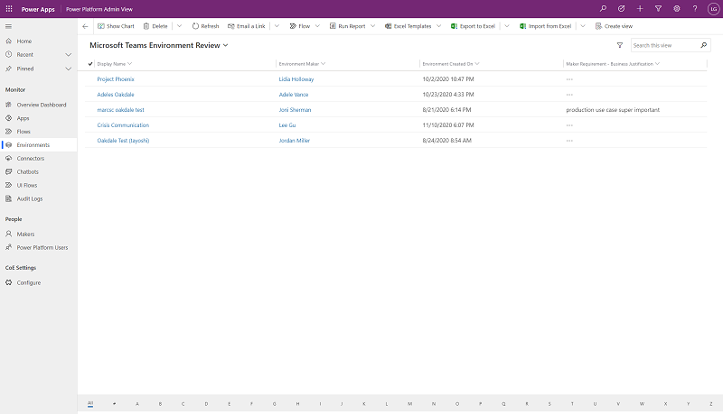
7. Open an environment and look at the business process flow to review the business justification, and approve or reject it.  
   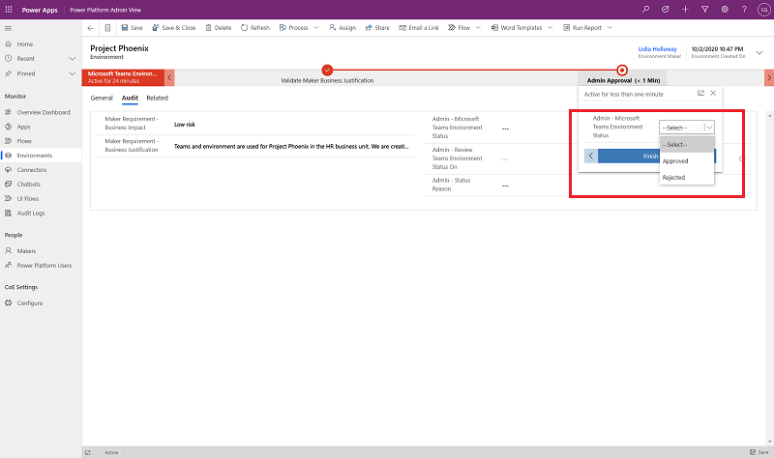
8. Environments with no business justification or with rejected business justification will be deleted during the next clean-up run.